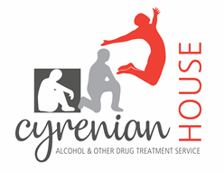
VOLUNTEER DRUG AND ALCOHOL COUNSELLORS’ TRAINING PROGRAM APPLICATION FORM - 2020

PLEASE NOTE
- This application is limited to 3 pages. Please ensure you adhere to this guideline.
- Due to the high number of applications received, feedback on unsuccessful applications unfortunately cannot be provided

First Name: |  |  |  |  | Surname:
Date of Birth:
Home Address:

Suburb: |  |  |  |  | Post Code:
Home Phone: |  |  |  |  | Mobile Phone:
Email:

- Overview of educational background:

- Overview of occupational background:

- Previous counselling experience, if any:

- Why are you interested in being a volunteer counsellor?

- What is your interest in the Alcohol and drug field?

- Any other information you would like to include?

How did you hear about the Cyrenian House Volunteer Program?

REFERENCES

Please supply the name and contact information of two referees.

Please email all completed applications to Nicola Iannantuoni.
nicola.iannantuoni@cyrenianhouse.com

